# **CTF Topic: Code Analysis**



# **Introduction**

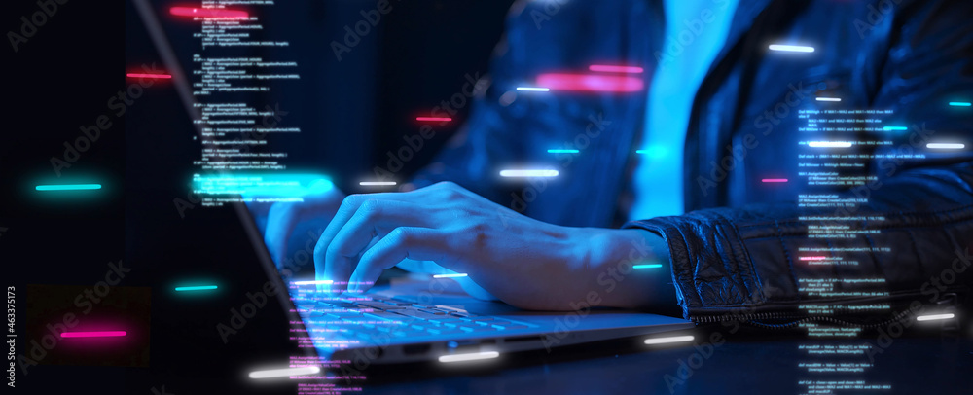

Binary code is a number system that uses only two digits: 0 and 1. It is the most fundamental language of computers, as it is the basis for all computer programming and data storage. Binary code is used to represent text, images, audio, and video files, as well as to store and process data in computers.

Hexadecimal code, also known as hex code, is a number system that uses 16 distinct symbols: 0-9 and A-F (which represent the numbers 10-15). It is a human-readable representation of binary code, making it easier for humans to work with binary data.

# **Tools and requirements**

ascitohex

# **Scenario**

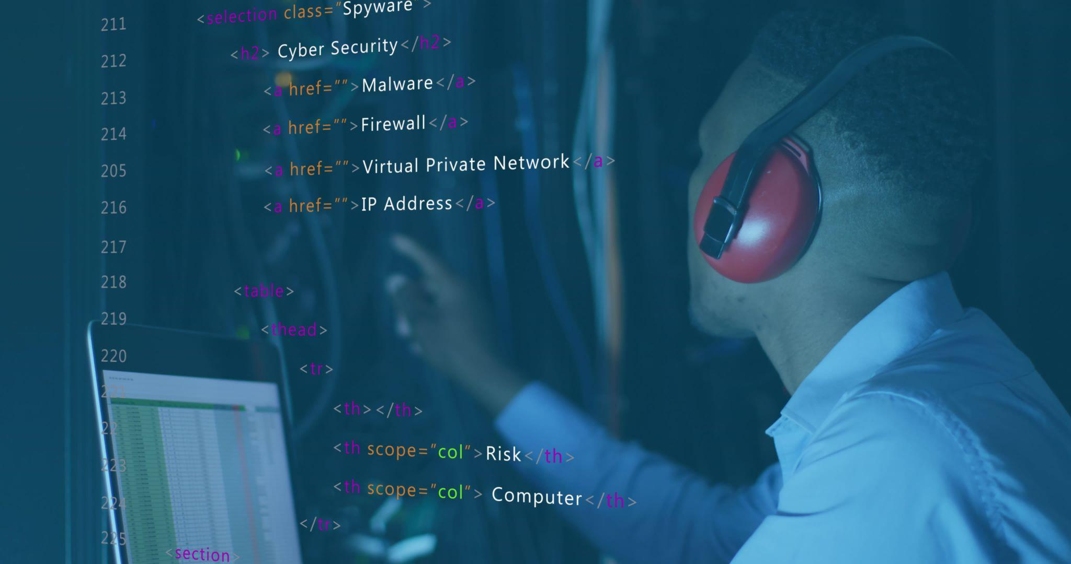

Ram wants to make a program that understands the communication with decimal and hexadecimal code between the devices while on execution of code.

# **Process to Perform**

Step 1: Go to the link: <https://www.asciitohex.com/>

Step 2: And enter text **ING skill** and do convert.

Step 3: Capture the flag

# 

# **Let’s start the Challenge**

# **Question**

**Flag 1: What is the binary code of the text ING Skill?**

**Answer: 01001001 01001110 01000111 00100000 01110011 01101011 01101001 01101100 01101100**

**Flag Captured.**

**Flag 2: What is the hex code of the text?**

**Answer: 49 4e 47 20 73 6b 69 6c 6c**

**Flag Captured.**

# **Hint**

